Name ___________________ #___
Date _____________ Pd. ___
Design a Submarine Project
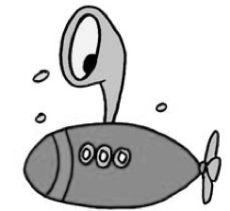
For this project, you will be working in a group of 2-3 people. Your group will need to make a google slides presentation to showcase your work. Your group will also need to present your poster to the class.

Project Questions:
These questions are to be answered on the conclusions slide.
- How did your submarine(s) show that density and buoyancy are related?
- Explain what a hovering submarine is using the words density, buoyancy, weight and buoyant force.
- How did your submarine(s) show that weight and buoyant force are related?

Project Objectives:
- With your team, plan and decide on materials to put inside a film canister to make it float, hover and sink in a beaker of water.
- Engineer and test each submarine.
- REMEMBER, YOU NEED A SINKING, FLOATING, AND HOVERING SUBMARINE.
- With the successful submarines, find the mass (using a balance), volume, and density.
- Create a google slides presentation to showcase work.
  - Title Slide
  - List the final materials inside each submarine.
  - Explain planning and modifications of submarines.
- On 1 or 2 slides, state what the initial plans were for each submarine and the modifications made to each to achieve floating, hovering and sinking.
  - Draw a force diagram (include only F_{B} and F_{G}) for each submarine.
- Find the weight of each submarine
- Find the buoyant force ( 1 g = 1 mL)
- You may want to include pictures of your submarines on this slide.
  - Write conclusions.
- Answer Project Questions using complete sentences.

Points Possible: _____________ DUE DATE: _____________

